|  |
| --- |
| A picture of a winding road and trees  fundamental of computer programming  LAB TASKS |

NAME : HANAN MAJEED

CMS ID: 519166

CLASS : BSDS_02_A

LAB : 02

TASK A:

Write a program that prints your name, registration number, semester, and GPA on separate lines with proper spaces. A sample output is shown below:

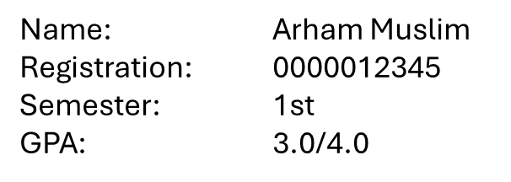

SOLUTION:

INPUT DATA:(A)

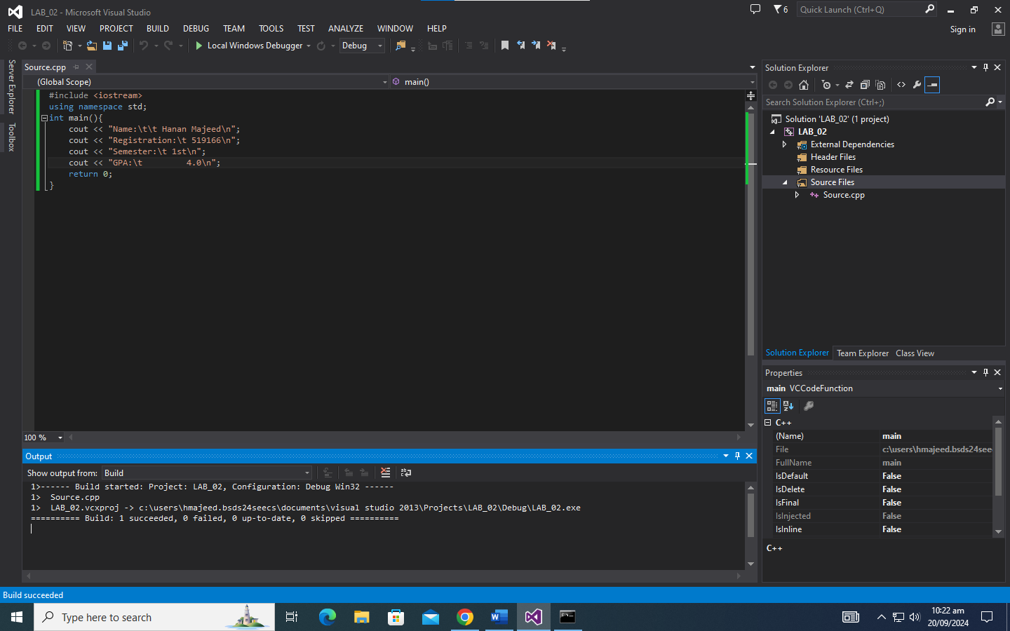

OUTPUT:(A)

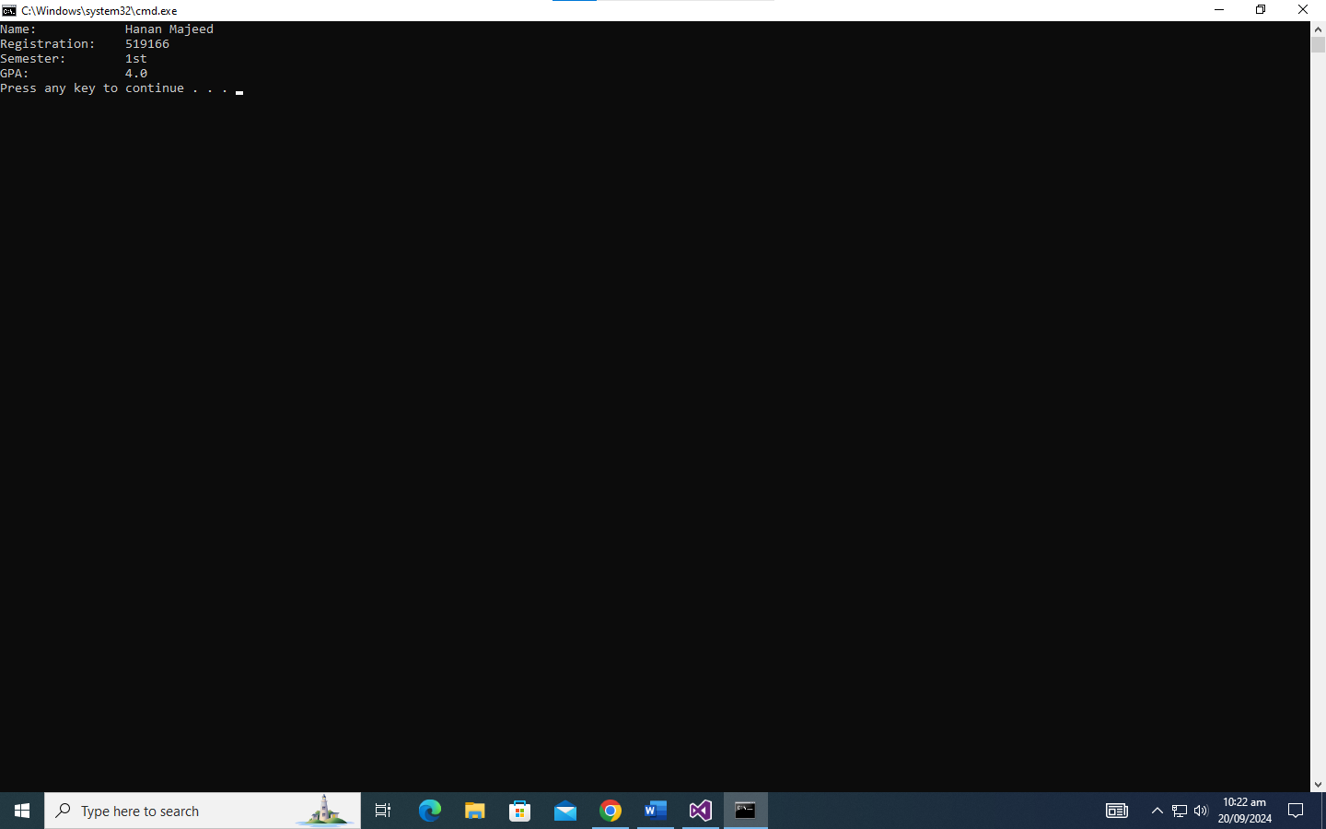

TASK B:

Write a program that prints your favorite quote/saying in a proper format.

Note: Don’t forget to use quotation marks and the writer’s name. A sample output is shown below:

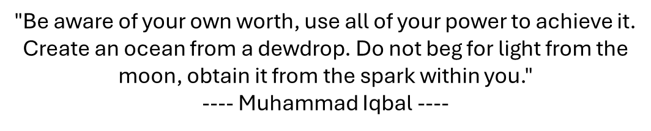

SOLUTION:

INPUT DATA:(B)

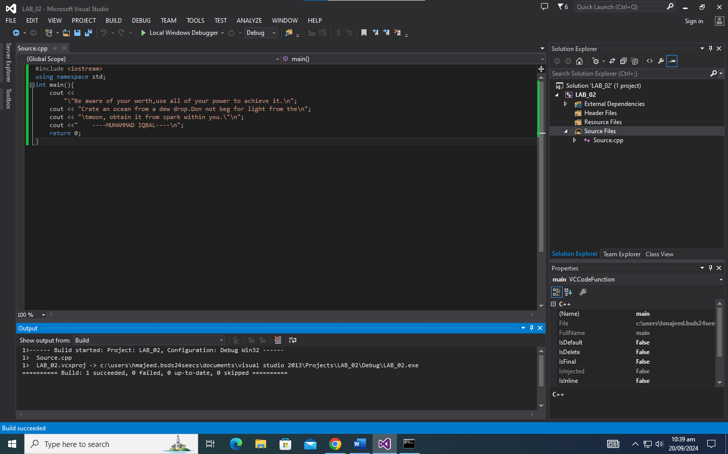

OUTPUT:(B)

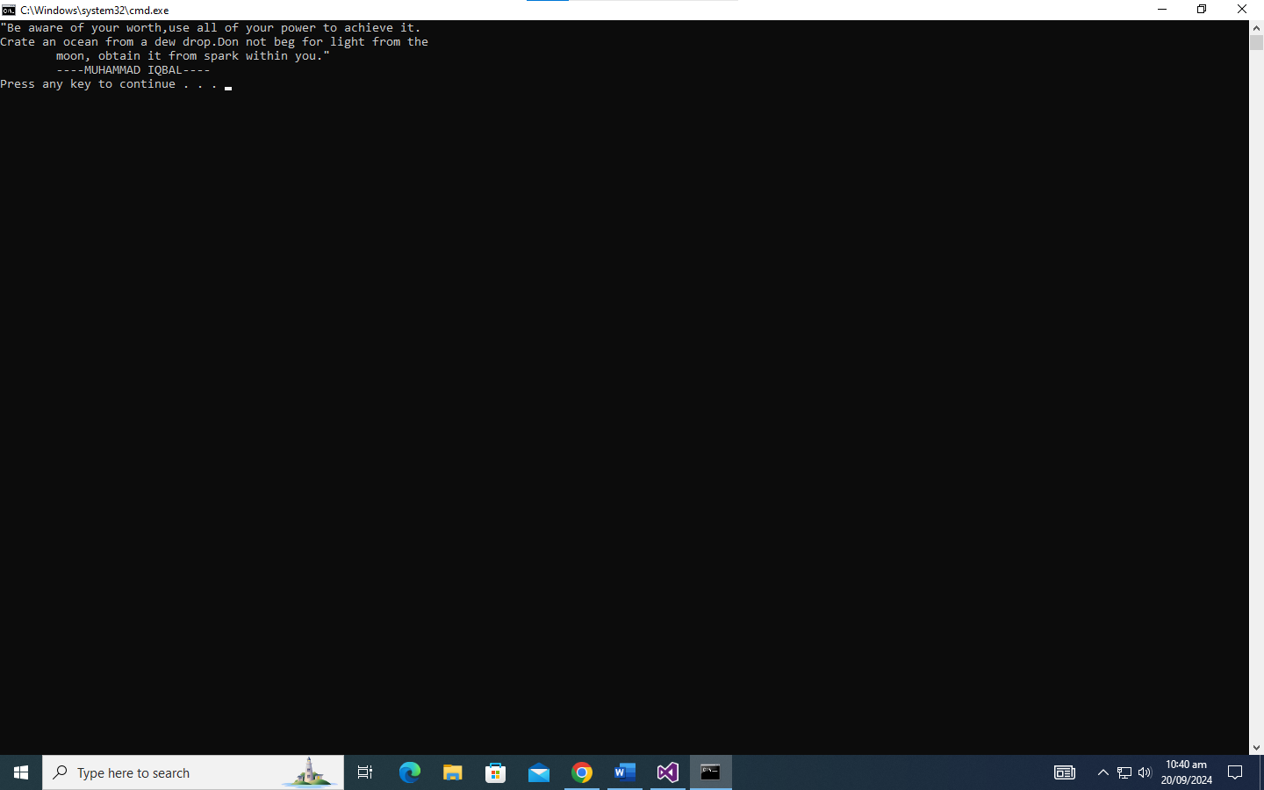

TASK C:

Write a program that displays your name and address on the screen as a visiting card. Your output should look roughly like the one shown below.

Note: Try using a single cout statement and escape sequence to print your letter.

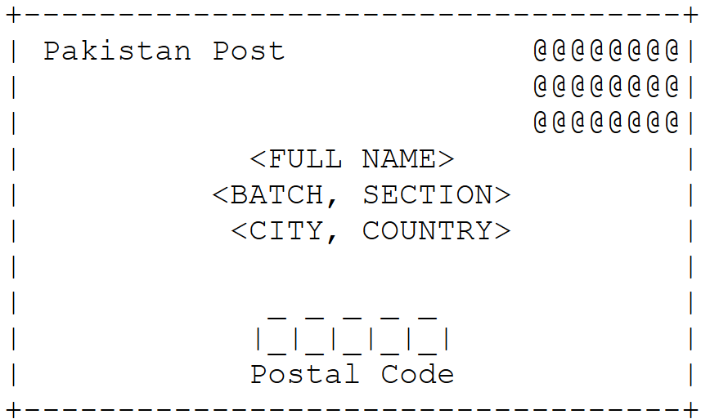

SOLUTION:

INPUT DATA:(C)

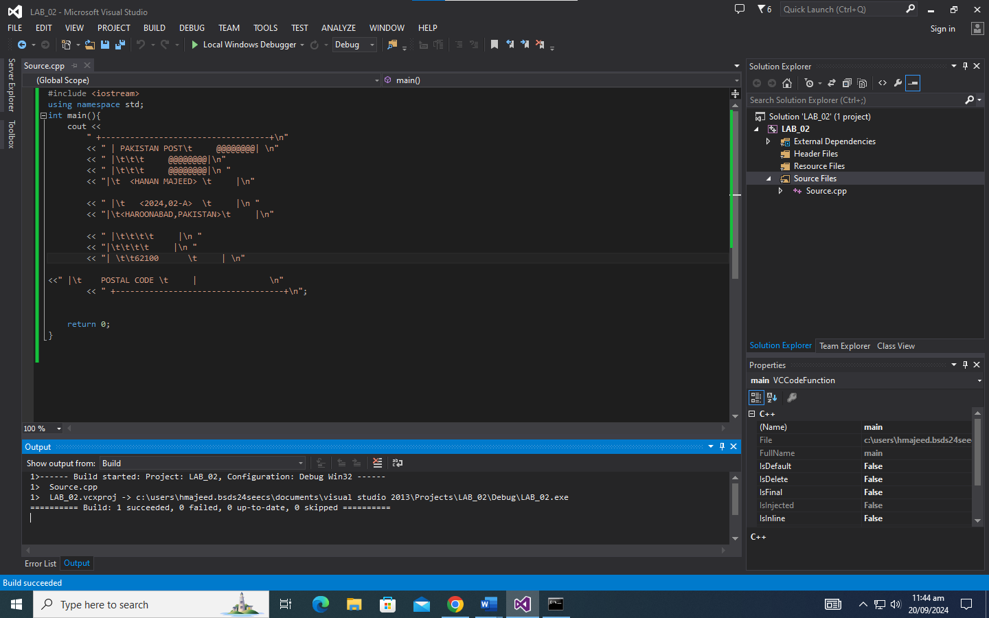

OUTPUT:(C)

